FMC AMS Onboarding Document
Contents
Fresenius Account Setup 3
Fresenius Zid and Email-id 3
Accounts Setup 3
Citrix Installation 3
Azure DevOps access 3
AWS Portal Access 4
Ticketing Portal access 4
Quick Service Portal Access 4
Service Now Portal Access 4
Windchill Application Access 5
Windchill GPDM/Thingworx Application Access 5
Windchill NA Application Access 5
Blue.Space Access 6
Jira 6
CyberArk 6
Required Documentation & Organizational Understanding 7
Associate Base Details 7
Organization Structure 7
Mandatory Training 7
PTC Account 7
PTC Windchill Mandatory Trainings: 7
Business Overview and Healthcare Domain Courses 7
Bluebolt Courses 8
GenAI Mandatory Courses 8

Checklist | Status
Fresenius ZID and Email-id
Citrix Software Installation
FMC account setup
FME VDI Connectivity
Quick Service Portal Access
Service Now Portal Access
PTC Account Creation
PTC Mandatory Training and others
Windchill/ Thingworx Application Access
Windchill Application NA
AWS Account Access
Devops Access
Jira Access
Bluespace
CyberArk

Fresenius Account Setup

Fresenius Zid and Email-id
Please connect to Reporting Manager and get Fresenius Email-id and Zid to setup the account.
You can also check the latest update here if Tracker is alive.

Accounts Setup
Once Email-id and Zid are received, please follow below guide to setup your FME account:
<I am going to add one document here>
Please refer below additional documents for any related help:
- FME AMS - Resource On Boarding Guide.docx

Citrix Installation
Please install Citrix in Laptop to connect to VDI.

Azure DevOps access
Azure Devops application is used to report any GPMD Production related Issue/bugs/enhancements. AzureDevops also has Its own WiKi page to store Knowledge articles.
How to get the access:
To get access to DevOps, please write an email to Ravi Vuta, requesting access to Devops
How to Validate the access:
Once access is granted, please verify the same by accessing below link -
https://dev.azure.com/FreseniusMedicalCare/PDM%20-%20Product%20Data%20Management

AWS Portal Access
AWS Portal access is needed to access GPDM application. It has Session Manager, Secret Manager, S3 etc which will help anytime during the work.
How to get the access:
- Please connect your RM and list down the Application accounts where access is needed.
- Please write an email to ‘GPDM-L1-Suppport@freseniusmedicalcare.com’ following approval from Ravi Vuta and request ‘AWSPowerUserAccess ‘access for the required accounts.

How to Validate the access:
Link to verify access - https://d-99672be81d.awsapps.com/start/

Ticketing Portal access

Quick Service Portal Access
How to get the access:
- Please connect your RM and list down the Projects where access is needed.
- Please write an email to ‘Ritesh Nagori’ and request access for the required Projects.

How to Validate the access:
Link to verify access - Navigate to Browse Projects → QuickService

Service Now Portal Access
How to get the access:
- Create a servicenow access request similar to INC3067291
How to Validate the access:
Link to verify access - https://fmcna.service-now.com/

Windchill Application Access

Windchill GPDM/Thingworx Application Access
How to get the access:
- Please complete the PTC Windchill Mandatory Trainings to avail access for applications.
- Connect with your RM and identify the required access in application.
- Please open a QuickService GPDM ticket and request the required access.

How to Validate the access:
Credentials will be shared to you via email. Please use below application URL to access the application -
Production server: https://plm.wc.gpdm-euc1.fmcglobal.net/Windchill
SBX server link : https://plmsb.wc-sbx.gpdm-euc1.fmcglobal.net/Windchill
Dev server link : https://plmdev.wc-dev.gpdm-euc1.fmcglobal.net/Windchill
QA server link : plmqa.wc-qa.gpdm-euc1.fmcglobal.net/Windchill/app/
Production server: https://app.twx.gpdm-euc1.fmcglobal.net/Thingworx/Composer/
QA server link: https://appqa.twx-qa.aws.gpdm.fresenius.com/Thingworx/Composer/
Dev server link: https://appdev.twx-dev.gpdm-euc1.fmcglobal.net/Thingworx/Composer/
SBX server link: https://appsb.twx-sbx.gpdm-euc1.fmcglobal.net/Thingworx/Composer/

Windchill NA Application Access
How to get the access:
- Connect with your RM and identify the required access in application.
- Please complete the mandatory PTC trainings to avail access for applications.
- Please open a ServiceNow ticket and request the required access.

How to Validate the access:
Credentials will be shared via the email. Please use below application URL to access the application -
Production Server: https://windchill.fmcna.com/Windchill
Training Server: http://hal-wc11tra-ps01.dc.fmcna.com/Windchill
Dev Server: https://windchill-dev.fmcna.com/Windchill
QA Server: https://windchill-qa.fmcna.com/Windchill

Blue.Space Access
How to get the access:
Please write an email to ‘Ritesh Nagori’ and request access to BlueSpace.

How to Validate the access:
Link to verify access - https://bluespace.fmeone.com/pages/viewpage.action?pageId=31702660&spaceKey=GlobalPDM&title=GPDM%2BWindchill

Jira
Jira application is used to report any Windchill NA Production related Issue/bugs/enhancements.
How to get the access:
Please write an email to ‘Ravi Vuta’ and request access to Jira Portal.

How to Validate the access:
Link to verify access - https://fresenius.atlassian.net/jira/software/c/projects/GTOSYS/issues

CyberArk
CyberArk access will help in connecting Windchill NA Windows instance.
How to get the access:
Please write an email to ‘Ravi Vuta’ and request for CyberArk access.

How to Validate the access:
Link to verify access - https://fmcsecurelogin.fmcna.com/PasswordVault/v10/Accounts

Required Documentation & Organizational Understanding

Associate Base Details
Complete: FME AMS AD Associates.xlsx

Organization Structure
Review: FME AMS RFP – Team Structure – v1.0.pptx

Mandatory Training

PTC Account
Associate should create a PTC account using the Fresenius email id. Please collect the required details from RM to create PTC account.

PTC Windchill Mandatory Trainings:
Associate must go through below PTC Mandatory Training to get access to Windchill GPDM and Windchill NA Application access:
Module 1 | BUSINESS ADMINISTRATION  Windchill: Introduction and Context Administration,  Windchill: Participants and Tes, Windchill: Objects and Types,  Windchill: Access Control,  Windchill: Introduction to Windchill Business Reporting,  Windchill: Introduction to Part Classification
Module 2 | CHANGE MANAGEMENT ADMINISTRATION  Windchill: Automate Change Processes,  Windchill: Change Implementation,  Windchill: Tailoring Change Management
Module 3 | SYSTEM ADMINISTRATION  Windchill: Installation and Configuration Overview,  Windchill: Properties and Monitoring, Windchill: File Vaulting and Replication,  Windchill: Maintenance Activities, Windchill: Tuning and Backup,  Windchill: Configuring Automated Publishing

Business Overview and Healthcare Domain Courses
Complete: FME Onboarding – Domain Mandatory Courses
Watch: FME – Business Overview Recording

Bluebolt Courses
Complete all required Bluebolt modules:
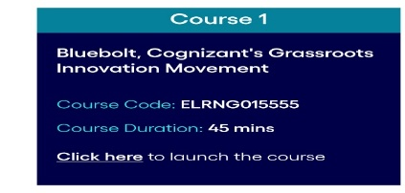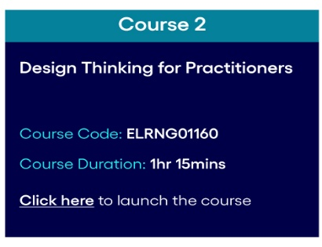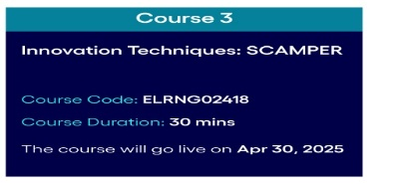

GenAI Mandatory Courses
Course Name | Course link | Recommended Levels | Hours
INTRODUCTION TO GENERATIVE ARTIFICIAL INTELLIGENCE (GEN AI) [101-BASICS] CLearn - ELRNG00441 | Click Here | PE to GM (who have not completed) | 2.5 Hrs
CLearn Quick Assessment - GEN AI FOR IOA - QUIZ [101 - BASICS] CLearn - ATHAU322985 | Click Here | PE to GM (who have not completed) | 1.15 Hrs
Prompt Engineering Foundation [101-BASICS] CLearn - ELRNG02100 | Click Here | PE to GM | 5 Hrs
Prompt Engineering Hands on exercises | Click Here | PE to GM | 0.5 Hrs
Prompt Engineering Foundation Knowledge Based Assessment [101-BASICS] CLearn - ATHGI345441 | Click Here | PE to GM | 2 Hrs
Gen AI Skills for Leaders | Click Here | SDM to Sr.Director | 2 Hrs 12 minute

Distribution List
Please request your RM/POC to add in below Distribution List:
FMC.AMS.Support
WIndhcill_AMS

